**KidLang Preprocessing Guide**

**Tasks =** Dialogue, Production, Comprehension (*Listening* in the scripts), and Reading

**Conditions =** Phrase, Object, and Baseline

**Epochs Lengths**

***Dialogue/Listening/Reading***

*Phrase & Object* → -0.7 to 2s

*Baseline* → -0.7 to -0.5s

***Production***

*Phrase & Object* → -0.1 to 5s

*Baseline* → -0.1 to 0s

|  |  |  |  |  |
| --- | --- | --- | --- | --- |
| **TRIGGER IDs** | ***dialogue*** | ***listening*** | ***reading*** | ***production*** |
| ***phrase*** | 18 | 20 | 24 | 17 |
| ***object*** | 34 | 36 | 40 | 33 |
| ***baseline*** | 66 | 68 | 72 | 65 |

**Navigating the NY server**

**Connecting to the NY server:**

1. *In finder, click command + k*
2. *Type smb://nellabny.psych.nyu.edu/server*

**Scripts you will need in NEUROLING > Projects > KidLang**

* **kidlang_Jan2021.yml →** KidLang (most recent is Jan2021)
* **KidLang.py →** KidLang > kids > maindataset
* **create_individual_production_logs.R →** KidLang > behavioral_analyses
* **1_preproc_forav.py →** KidLang > kids > production
* **2_preproc_backav.py →** KidLang > kids > production
* **plot_stcs_kids.py →** KidLang > kids > production
* **roi_anova.py →** KidLang > kids > production
* **run_stats_kids.py →** KidLang > kids > production
* **average_plotting_all_contrasts.py →** KidLang > kids > maindataset
* **average_plotting_1_contrast.py →** KidLang > kids > maindataset

I tend to make my own copies of each of the above scripts & add **_sherine** at the end of each file name to keep track of them all.

**Before you start**

**Your working directory will be the ~/KidLang folder, in that folder you will have two folders (*in lower case*!):**

1. ~KidLang/meg
2. ~/KidLang/mri

**(1) In the meg folder, you will have subfolders for each of your subjects.**

**So in ~KidLang/meg/A0422, you will need to have:**

* Marker files (depending on how many marker measurements you took, it’s usually two): -1.mrk, -2.mrk, etc
* _NR.con file
* -basic.txt file
* -points.txt file

**(2) In the mri folder, you will just have the fsaverage folder (~KidLang/mri/fsaverage)**

**Using the right eelbrain environment**

Right now, the lab is using **version 31.8 (as of January 2021).** If you’re going to be preprocessing & running these scripts for the first time, follow these steps.

**1)** In the NY server *( ~/NEUROLING/Projects/KidLang*), copy kidlang_Jan2021.yml into your working directory. This is a file that contains the environment you need with the right combination of packages.

**2)** Open terminal and change your working directory.

cd /Users/Sherine/Desktop/KidLang

**3)** Create your new environment.

conda env create -f kidlang_Jan2021.yml

***Note:*** *different tasks are preprocessed using different pipelines. Production is preprocessed using the MNE pipeline, and dialogue/listening/reading are preprocessed using the eelbrain environment. You won’t have to do anything extra, just follow the steps in the guide. This is just to let you know.*

**Converting raw to fiff files**

**1)** Open Terminal & change your working directory.

cd /Users/Sherine/Desktop/KidLang

**2)** Activate the MNE environment.

conda activate mne

**3)** Now, open the GUI that will convert your raw file (_NR.con) to a .fiff file.

mne kit2fiff

**4)** This is what the GUI should look like!

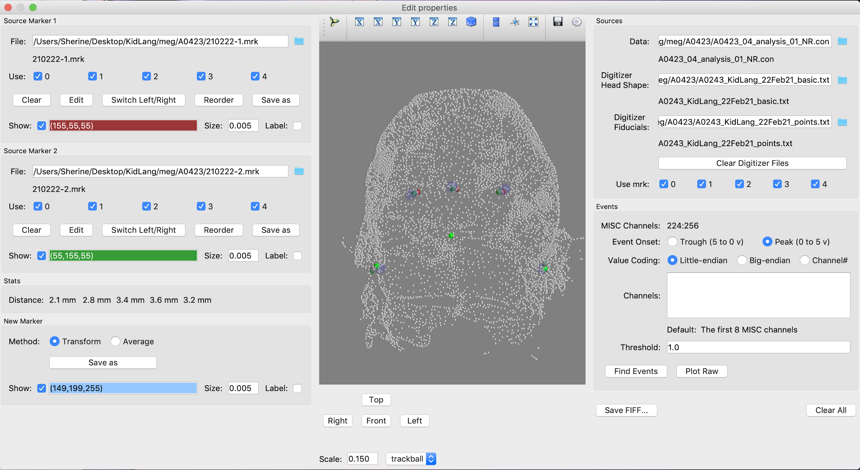



These are the files you should upload:

* Under Source Marker 1 → first marker measurement file



* Under Source Marker 2 → second marker measurement file



* For *Data* → _NR.con file



* For *Digitizer Head Shape* → _basic.txt file



* For Digitizer Fiducials → _points.txt file



On bottom left of the GUI, under Stats, make sure **none of the values exceed 20mm**. These values are the **difference in distance between the first and second marker measurement**.

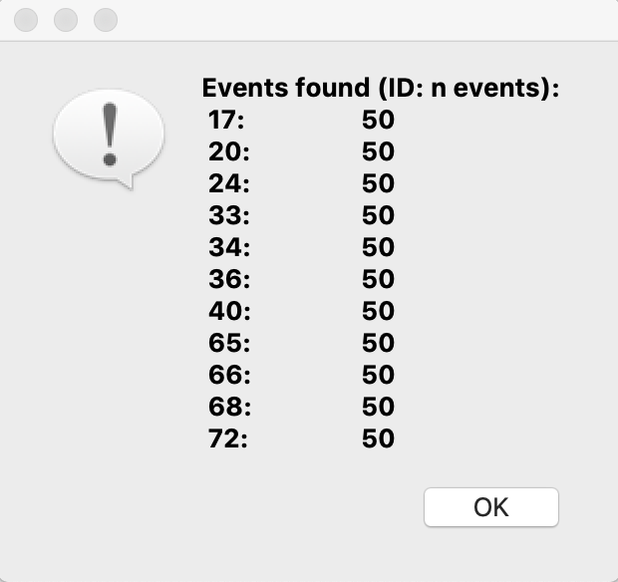**5)** Click on *“Find Events”* on the bottom right to double check your triggers and number of events. This window should pop up.

The column of numbers on the right is for the **TRIGGER IDs** and the one on the left is for the **NUMBER OF EVENTS** (trials) per trigger ID. Ideally, the GUI should identify **12** trigger IDs (*4 tasks x 3 conditions*) and 50 events/trials per trigger.

*However,* this isn’t always the case. In the picture above, trigger 18 is missing which is corresponds to phrase dialogue.

* *This should be fixed* ***(as of August 2021)***

**6)** Last step! Click on *“Save FIFF…”* on the bottom to save your converted file, and name it according to this format = **subjected_KidLang-raw**. Make sure you save it in the right directory! You can close the GUI once it says the file is saved (terminal will also say [done]).

**If you have more than one _NR.con file**

This happens when your subject did different tasks on different days, or took long breaks in between tasks.

*For example, let’s say this is how your session went:*

Marker measurement 1 → dialogue+production_NR.con → marker measurement 2 → comprehensions_NR.con → marker measurement 3

**1)** **Do steps 1-6 as you normally would**, but you will have to do them ***TWICE***.

The first time, you will use marker measurements 1 & 2 with the dialogue+production_NR.con file. You will save this .fif file as **subjectid_01_KidLang-raw**

The second time, you will use marker measurements 2 & 3 with the comprehensions_NR.con file. You will save this .fif file as **subjectid_02_KidLang-raw**

**2)** Now you’re going to concatenate the subjectid_01_KidLang-raw.fif and subjectid_02_KidLang-raw.fif files. Reopen terminal and change your working directory to where you keep these two .fif files.

cd /Users/Sherine/Desktop/KidLang/meg/A0423

**3)** Activate the eelbrain environment.

conda activate eelbrain

eelbrain

**4)** Import MNE.

import mne

**5)** Assign a variable to your first .fif file.

fif1 = mne.io.read_raw_fif(‘A0423_01_KidLang-raw.fif’)

*To see if this worked, type* fif1 *into terminal*.

**6)** Assign another variable to your second .fif file. Do this for as many .fif files you have!

fif2 = mne.io.read_raw_fif(‘A0423_02_KidLang-raw.fif’)

**7)** Concatenate them.

fifs = mne.concatenate_raws[(fif1, fif2)]

**8)** Save them as one .fif file! *Remember to use the same naming format as above.*

fifs.save(‘A0423_KidLang-raw.fif’)

**Coregistration**

**1)** In terminal, activate the MNE environment.

conda activate mne

**2)** Open the coregistration GUI.

mne coreg

**3)** This is what the GUI looks like.

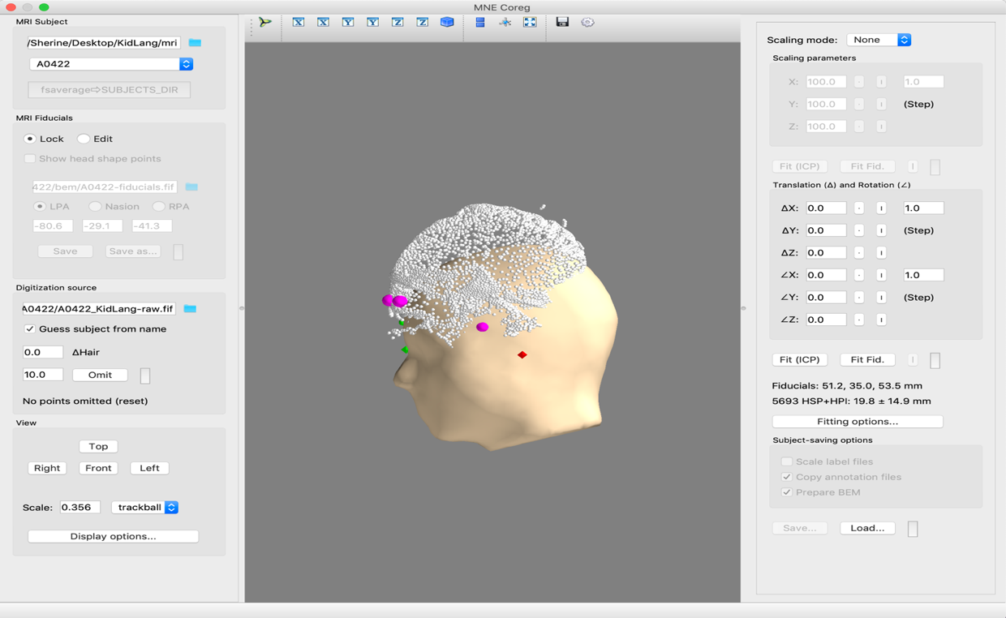



These are the files you should upload:

* Under “MRI Subject” → the directory to your ***mri folder*** *NOT the fsaverage or the subject*



* Under “Digitization Source” → subjectid_KidLang-raw.fif file *not the -raw-1.fif file*



***Note:*** *if you don’t see a yellow head after uploading everything, reopen terminal and run the coregistration commands again.*

**4)** There’s a dropdown menu below the mri directory (yellow).

Select fsaverage if your subject doesn’t have an MRI, or select the subject’s ID if they do.

***Note:*** *if you are re-preprocessing a subject you already used fsaverage for before, and you go to select an mri for their coregistration, you will see an option in the dropdown menu with their ID. This is just the fsaverage brain that is assigned to them (with their fiducials etc)*

**5)** In the top right, set *“Scaling mode”* to **3-axis.**

**6)** Now, try to make the points fit on the subject’s head by playing around with the buttons on the right (**the xyz axes**), and/or by clicking on “*Fit (ICP)*” or “*Fit Fid.*”

**7)** Uncheck “*Scale label files*” on the bottom right.

**8)** Click **save!** You might get a popup asking for the participant’s name, so make sure it’s the correct ID. You should now have a -trans file saved in your directory.

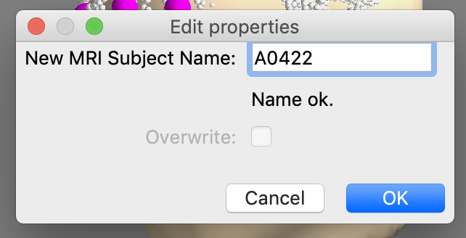

***NOTE:*** *keep an eye out on terminal to see whether it’s done saving/computing the coregistration! Make sure that the bottom of the GUI notifies you that the file is saved,* ***AND*** *terminal says something like [done] or “BEM geometry computations complete”. If the bottom of the GUI still says it’s computing BEM,* ***WAIT****!*

*Create a document (eg: A0422_info) for each participant where you will include screenshots of their* ***coregistration model****,* ***bad channels, ICA components****,* ***epochs rejected****,* ***STCs****, & anything else you want to note down while pre-processing! It’s good to keep track of these things.*

***STCs*: dialogue, reading, & listening data**

**1)** First step is to activate the eelbrain environment in terminal.

conda activate eelbrain

eelbrain

**2)** Make sure you have the right directories and subject IDs in **KidLang_sherine.py** script (*we will be using this script a lot, its directory is ~Users/Sherine/Desktop/KidLang*). When you’re done making the necessary edits, run the KidLang_sherine.py script.

run KidLang_sherine.py

What this script does is set up your experiment class, to check if it worked simply type e and check the output, it should look like this:

KidLang('/Users/Sherine/Desktop/KidLang', subject='A0422', raw='1-40', epoch='all_trials', equalize_evoked_count='eq')

**3) Removing bad channels.** Now you will plot all the MEG channels and exclude ones that seem to be misbehaving. I don’t usually remove any channels because data in AD is way cleaner than in NY, but it’s good to have a look.

raw = e.load_raw()

raw.plot()

Scroll vertically & horizontally to check for bad channels. Bad channels are ones that seem dead (have a straight line), or have HUGE peaks that intersect other channels throughout the recording. **Don’t remove channels that just seem noisy, you exclude these later!** If you find one you want to exclude, simply click on it and it will grey out.

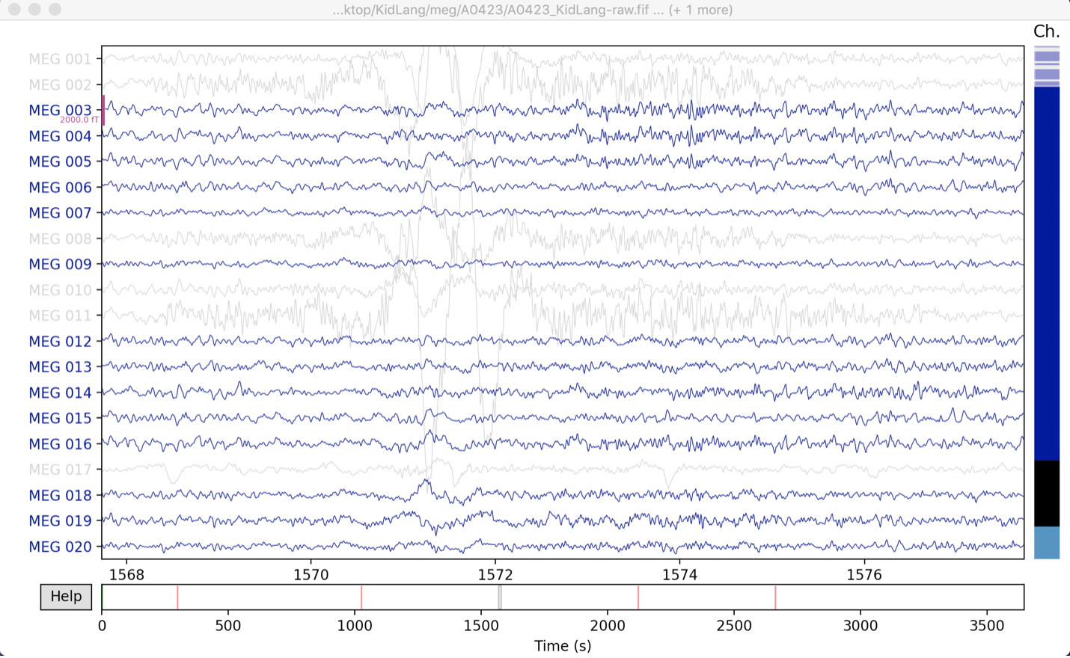

Once you’re done, close the GUI.

**4)** Rerun the KidLang_sherine.py script. This will now exclude any bad channels you excluded in the step before.

run KidLang_sherine.py

**5) ICA Rejection.** This is where you start removing noise components.

e.set(raw=’ica’)

e.make_ica_selection()

***NOTE****: THE ICA GUI WILL* ***TAKE TIME*** *TO SHOW UP (40 MINS – 2 HOURS). BE PATIENT AND LEAVE IT TO RUN! If it take more than 2 hours though, reopen terminal & try again.*

Once the ICA GUI pops up, look through all the headmaps for components you want to exclude from your data. Simply **click on the component you want to exclude**, you can also click on *“Sources”* to see each headmap’s waveform. Clicking on a waveform will automatically select the headmap in the green GUI.

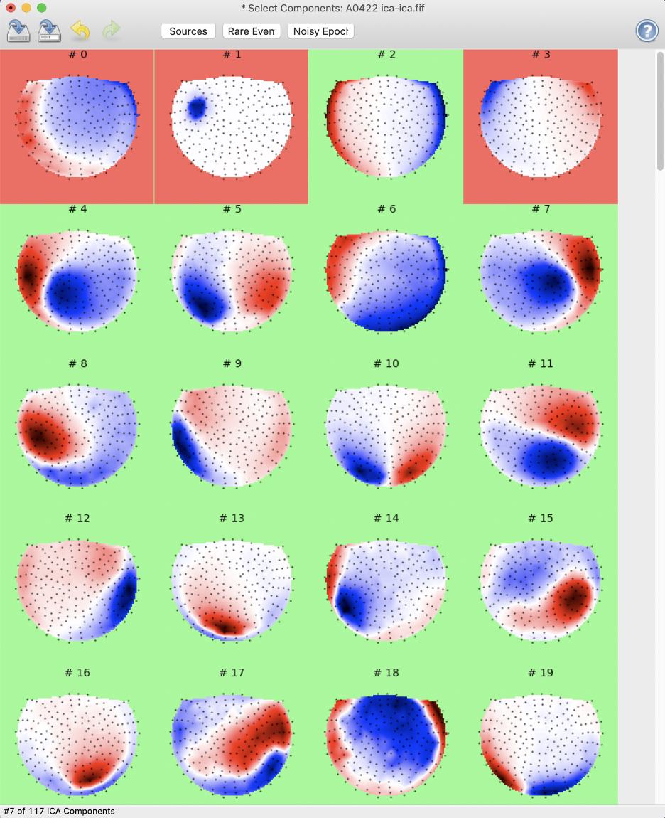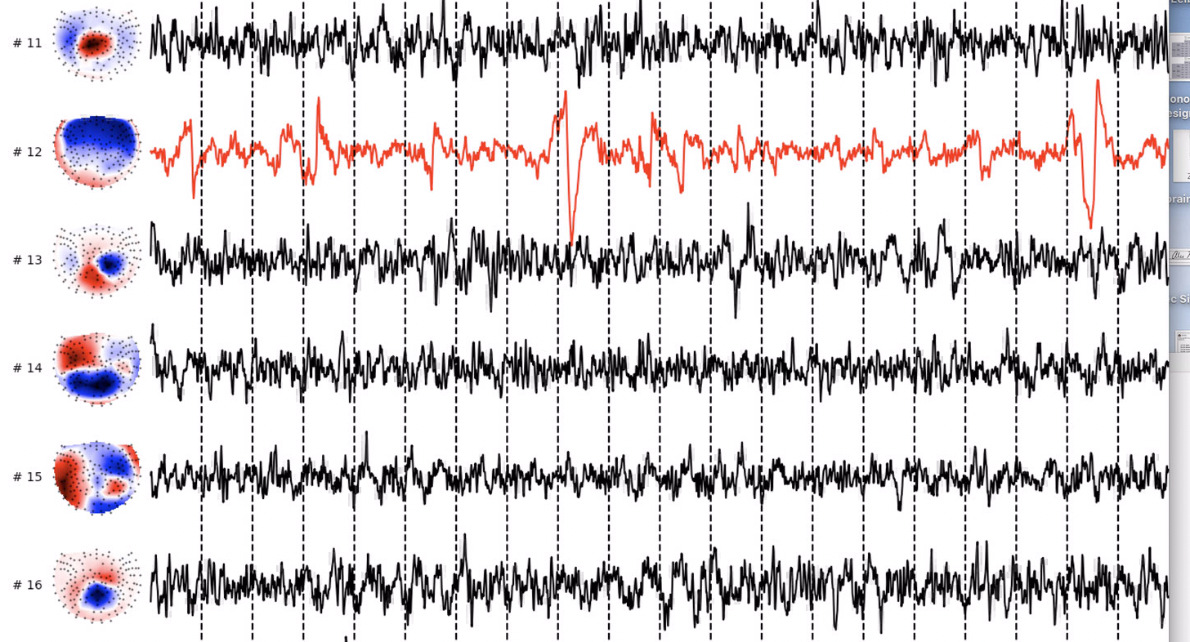

The ICA should save automatically. If it doesn’t, click on the second button on the top left (the save as button) and save it in your directory. Once it’s saved, you can close the GUI.

**6)** In terminal, make sure that your experiment class’ raw variable is set to ica.

e.set(raw=’ica’)

*This is going to be a line you’re going to have to* ***rerun*** *a couple of times throughout this process. Make sure* ***you keep checking*** *whether raw is set to ica by running* e *in terminal.*

KidLang('/Users/Sherine/Desktop/KidLang', subject='A0422', raw='ica', epoch='all_trials', equalize_evoked_count='eq')

**6)** **Epoch rejection.** You might have to reopen terminal if you’re trying to do this right after the ICA rejection. Either way, rerun the KidLang_sherine.py script.

run KidLang_sherine.py

Set your epochs variable to include all your trials.

e.set(epoch=“all_trials”)

*This is going to be a line you’re going to have to* ***rerun*** *a couple of times throughout this process. Make sure* ***you keep checking*** *whether epoch is set to all_trials by running* e *in terminal.*

KidLang('/Users/Sherine/Desktop/KidLang', subject='A0422', raw='ica', epoch='all_trials', equalize_evoked_count='eq')

Open the epoch selection GUI! (*This might also take a while, be patient*)

e.make_epoch_selection()

Once the epoch rejection GUI pops up, check that you have the correct number of events. You should have 600 events if you included all 4 tasks + their 3 conditions, or 450 events if you included on the dialogue, listening, and reading tasks. You can check how many events you have by clicking on the dropdown menu next to “*Page*”.

Then, go to “*Threshold*”, select “*absolute*” as the method, and set the magnitude to **2e-12**.

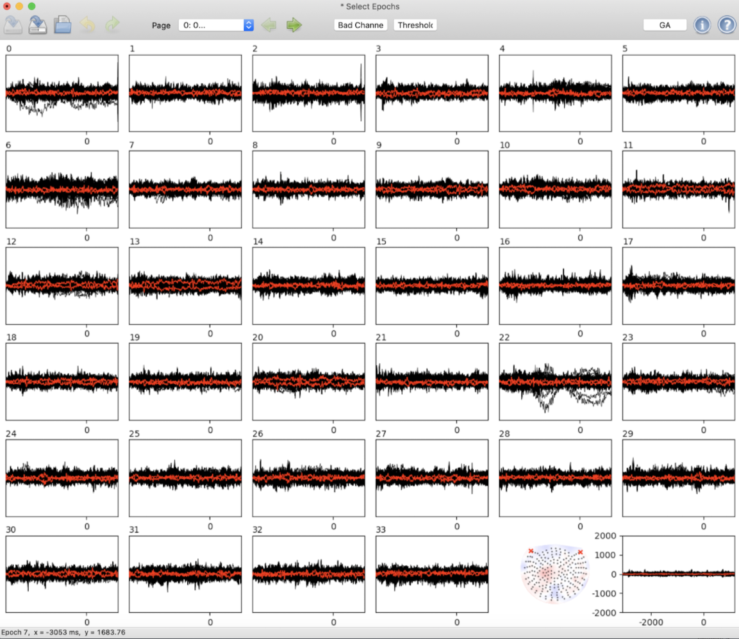

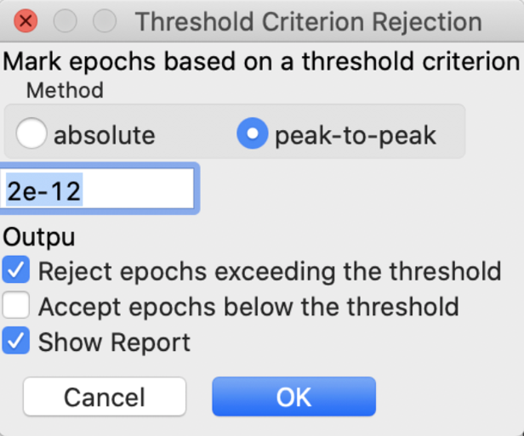

**Now click “*ok*”,** this will automatically reject epochs according to the threshold you set (this threshold doesn’t change). This method doesn’t always remove all the noisy epochs though, so go through them manually and check if anything needs to be removed. To reject them, simply click on them and they should become crossed out.

**Once you’re done,** click on the first and second save buttons on the top left, and change the file type from .txt to **.pickled!** Name the .pickle file this = **subjectid_KidLang_rejfile**. Once that’s done, you can close the GUI.

**7) Visualising evoked responses.** This will plot all your trials by ~condition%task.

e.plot_evoked()

This gives you a pretty large interactive file with **butterfly plots of all your tasks & conditions**. You can **hover your mouse** over different points on the plot to see what the activation looks like in your subject’s brain. You can save this file as a PDF, but you lose the mouse-hovering feature, so if you want to present specific topographic points of time, take screenshots!

*****

***NOTE!*** *MAKE SURE THAT IN THE EXPERIMENT CLASS e, raw IS SET TO ica AND epoch IS SET TO all_trials! Rerun the KidLang_sherine.py script if you have to.*

*These are the 4 or 5 lines you have to keep running:*

* *cd /Users/Sherine/Desktop/KidLang*
* *run KidLang_sherine.py*
* *e.set(subject=’A0423’) only when you’re moving on to the next subject!*
* *e.set(raw=‘ica’)*
* *e.set(epoch=‘all_trials’)*

*****

**8) STC creation.** STCs are files that have all the information you need about what brain areas are activated when.

e.make_mrat_stcs()

*Any issues you face here might be a coregistration issue, so if you do have trouble with this step, go back redo the coregistration part.*

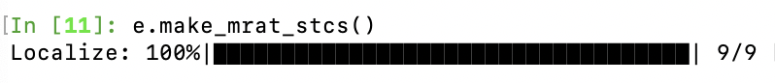

You should have **9 folders** being created (*or 12 if you included production in the variables in KidLang_sherine.py*). **These should be in your directory:**

KidLang > mrat > ica bestreg free-3-dSPM > all_trials condition%task man eq

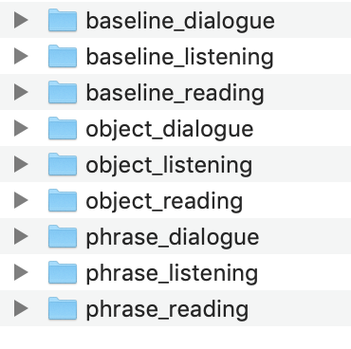

Each of the above folders should have **2 STC files** for **each hemisphere**.

***NOTE:*** you might have to rename the STC files to make them MRAT compatible, use this naming format = **[A/R number]_[task]_[condition]-[hemi]** (*eg:* *R0158_dialogue_baseline-lh*)

On my desktop, I have a *“KidLang STCs”* folder, where I make a copy of all the STCs with the correct naming format. Whenever I have new participants’ STCs, I edit the folder name to include the total number of participants whose STCs I’ve created.

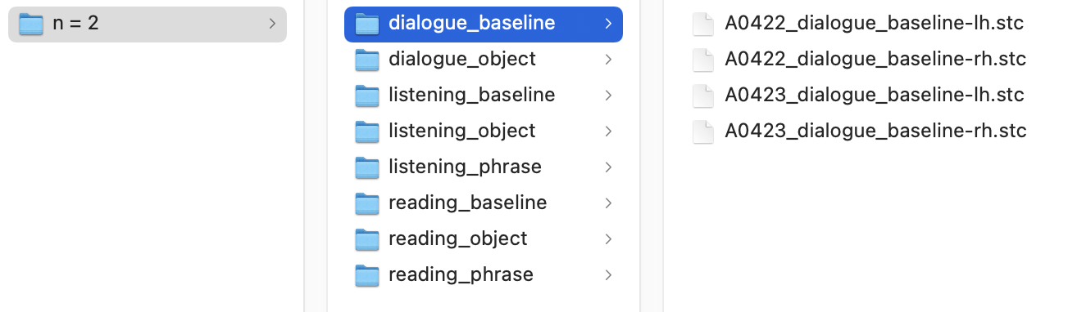

**9)** **IF YOU HAVE MORE THAN ONE SUBJECT.** If your KidLang_sherine.py script has multiple subject IDs, simply specify in terminal which subject you want to work with. So if I’m done working with subject A0422 and want to start with A0423, I will run these two commands

run KidLang_sherine.py

e.set(subject=‘A0423’)

Run e and check whether the subject is the one you want. You have to keep running that line!

KidLang('/Users/Sherine/Desktop/KidLang', subject='A0423', raw='1-40', epoch='all_trials', equalize_evoked_count='eq')

**10) Next, they will be uploaded to the KidLang Dropbox:**

* *KIDLANG > AD > Analysis > STCs > kidlang_n=2*

***STCs*: production data**

The reason as to why production has a different workflow is because the baselines for this task are different. Working directories for this task will also be different.

**1)** Create a **production folder** in your main directory and subfolders for each of your subjects.

**~/KidLang/production/meg/A0422**

**2)** In that folder, you want to **copy** over these:

* A0422_KidLang-raw.fif
* A0422_KidLang-raw-1.fif
* A0422-trans.fif *(if you’ve already done coregistration)*

**3)** After running your subject, each task will have two types of log files; a .log file and a .txt file. We are interested in the **.txt file**, especially for production data.

Rename them from **“A0422_production_202102241134.txt”** to **“A0422_production.txt”.**

Create a new log folder in the KidLang folder with subfolders for each participant, this is where you will store all their .txt log files. So move **A0422_production.txt** to **~/KidLang/logs/A0422**

***NOTE*:** *sometimes you have .txt files missing (don’t panic!), and if it’s the production .txt file that’s missing, you can’t do much with the production data.*

**4)** Now we’re going to open individual_production_logs_sherine.R script in RStudio. In that script, you will need to edit your **working directory** *(~/KidLang/logs/A0422)***, participant ID,** and **participant’s age.**

To get the participant’s age in years/months/days from their DOB, use this website: <https://www.timeanddate.com/date/duration.html>

**Also,** since trials in AD aren’t voice-activated, we get no reaction time data (and if you do, they might be unreliable). So in the R script, make sure that ***all trials are included*** *(add 1 to every ‘keep’ column).*

Quick guide as to what each dataframe you create includes:

* **Data →** all trials (noun + phrase + baseline)
* **RT_data →** noun + phrase trials
* **Backwards →** 100 trials (no baseline)
* **Forwards →** 150 trials (with baseline)

**5)** The script will give you these **3 files:**

* A scatterplot of reaction time data
* A .csv file with forwards averaged data *(production_forwards.csv)*
* A .csv file with backwards averaged data *(production_backwards.csv)*

***STCs*: production data: *forwards averaging***

**6)** These are the **four** scripts you will need in ~Users/Sherine/Desktop/KidLang:

* **1_1_mne_preprocessing_forav.py →** filter, bad channels, & ICA
* **1_2_mne_preprocessing_forav.py →** create epochs
* **1_3_mne_preprocessing_forav.py →** epoch rejection
* **1_4_mne_preprocessing_forav.py →** create STCs

In each of the scripts, you will have to edit your **working directory/ROOT**, **MRI directory** (which is just ROOT+**’/mri’**), and your **subject IDs.**

*They all used to be one script* ***(1_mne_preprocessing_forav_sherine.py)****, but it would take too long for the GUIs to pop up and you can never tell where you reached. So splitting them up into section makes the process faster & smoother. If you prefer working with one script, you can comment & uncomment the steps as you go along.*

**7)** Before we start analysing the data, activate the eelbrain environment in terminal.

conda activate eelbrain

eelbrain

**8)** Next, set your working directory.

cd /Users/Sherine/Desktop/KidLang

**9)** Now to run the first script: **filter, bad channels & ICA**! I usually comment out the part of the script that works with bad channels because they tend to behave well in AD, but make sure to **comment it back in** when you do want to check.

run 1_1_mne_preprocessing_forav.py

***NOTE****: THE ICA GUI WILL* ***TAKE TIME*** *TO SHOW UP (40 MINS – 2 HOURS). BE PATIENT AND LEAVE IT TO RUN! If it take more than 2 hours though, reopen terminal & try again.*

This is the **bad channels** GUI! Scroll vertically & horizontally to look for channels that seem noisy or dead. If you find one you need to exclude, simply click on it! Again, data is in AD is pretty clean you won’t usually need to exclude any. Once you’re done, simply close the GUI.

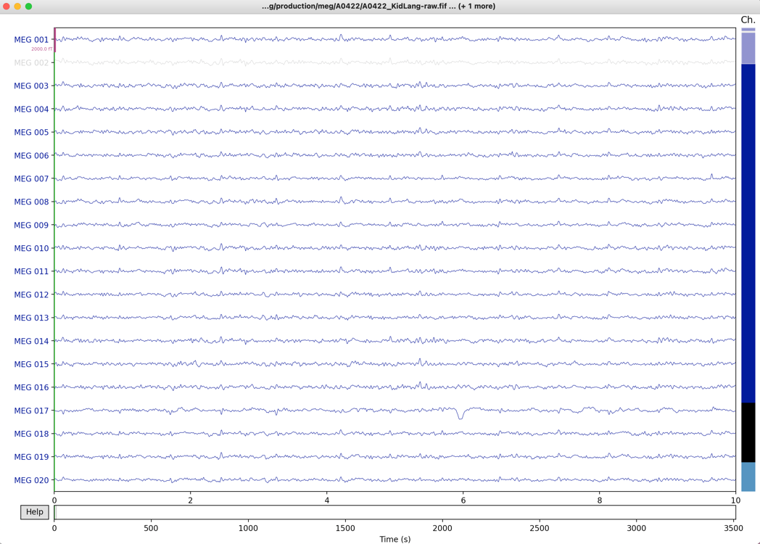

This is the **ICA** GUI! To exclude ICA components, simply click on them, and to see their respective headmaps, click on their ICA label on the y-axis and a separate window will pop up with a picture of the headmap. Once you’re done, simply close the GUI.

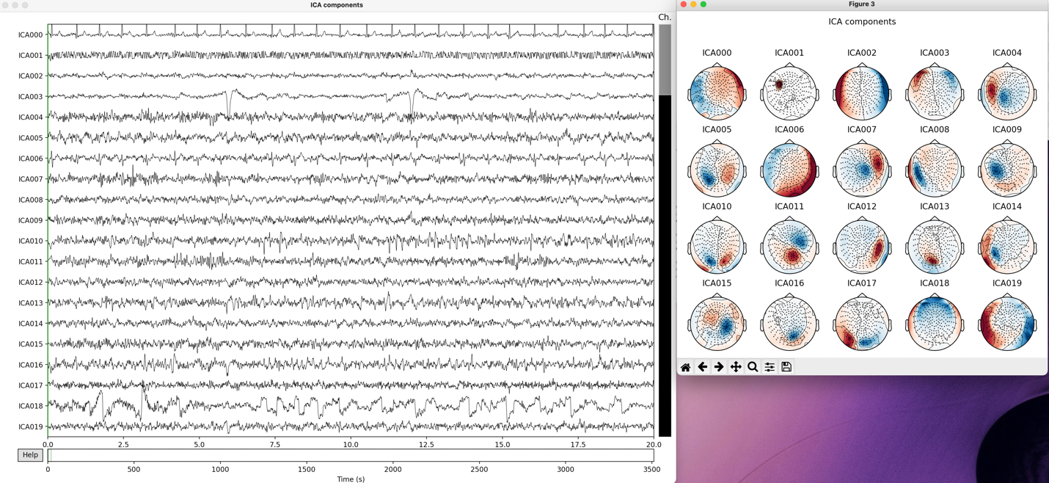

**10)** For the next step where you have to start working with epochs, I found that it’s best to start a new terminal session. So after you’re done using **1_1_mne_preprocessing_forav.py**, close terminal and re-open it. Then run the following (as usual):

conda activate eelbrain

eelbrain

cd /Users/Sherine/Desktop/KidLang

Now to run the second script: **creating epochs!** This script mainly does stuff behind the scenes so you won’t have to do much.

run 1_2_mne_preprocessing_forav.py

Once the script is done running (successfully), it will have saved & created these files & folders in your production directory:

* **subjectid_info.pickled** file
* **epochs_forAv** folder with these in it
  + **subjectid_baseline-epo.fif**
  + **subjectid_epochs-epo.fif**

**11)** Time to run the third script: **epoch rejection!**

run 1_3_mne_preprocessing_forav.py

First, check that you have the correct number of events by clicking on the dropdown menu next to “*Page*”. You should have 150 events for all 3 conditions of the production task.

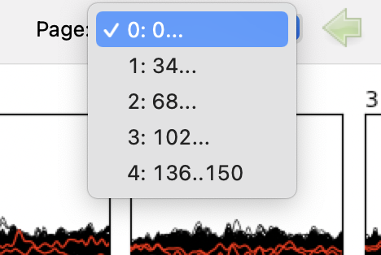

Then, go to “*Threshold*”, select “*absolute*” as the method, and make sure the magnitude is set to **2e-12**.





**Click “*ok*”,** this will automatically reject epochs according to the threshold you set (this threshold doesn’t change). This method doesn’t always remove all the noisy epochs though, so go through them manually and check if anything needs to be removed. To reject them, simply click on them and they should become crossed out.

**Once you’re done,** click on the first and second save buttons on the top left, and change the file type from .txt to **.pickled!** Name the .pickle file according to this naming format = **subjectid_KidLang_rejfile**. Make sure to save it in this directory: ~/KidLang/production/meg/A0422/epochs_forAV

You can close the GUI.

***NOTE:*** *sometimes you might have 0 rejected epochs, which is fine it just means you have super clean data (manually double-check just in case though)*

**12)** Time to run the fourth script: **STC creation!** There are a couple of things you have to do before running this script.

First, you have to **create a folder called ‘stc’** in ~/KidLang/production/ where all your STCs will be stored, and then in that folder, you will **create a subfolder called ‘forAv’**, *and finally* in that subfolder you will **create three more sub-subfolders** for each condition in the production task. This is what your ‘production’ folder should look like:

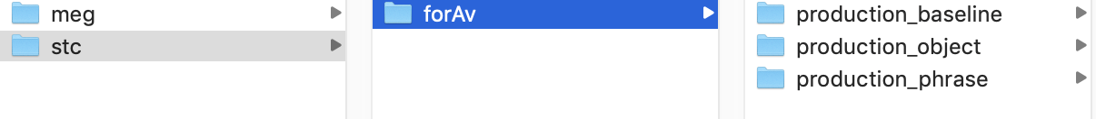

Second, *if* you happen to have had 0 rejected epochs, open **1_4_mne_preprocessing_forav.py**, comment out line 32 (loads epoch file with the rejected epochs) and comment in line 33 (loads epoch file as is)



**13) Now run the script!**

run 1_4_mne_preprocessing_forav.py

This will create your STCs and place them in the folders you created above! Remember, each condition will have two STCs for each hemisphere!



In addition to the STCs, this script creates these files:

* In ~/KidLang/production/meg/A0422/evoked
  + **subjectid_forwards.png** *(evoked response plot)*
* In ~/KidLang/production/meg/A0422/epochs_forAV
* **subjectid-cov.fif** *(the covariance matrix)*
* **subjectid-fwd.fif** *(the forward solution)*

***NOTE*:** you might have to rename the STC files to make them MRAT compatible, use this naming format = **[A/R number]_[task]_[condition]-[hemi]** (*eg:* *R0158_dialogue_baseline-lh*)

On my desktop, I have a *“KidLang STCs”* folder, where I make a copy of all the STCs with the correct naming format. Whenever I have new participants’ STCs, I edit the folder name to include the total number of participants whose STCs I’ve created.

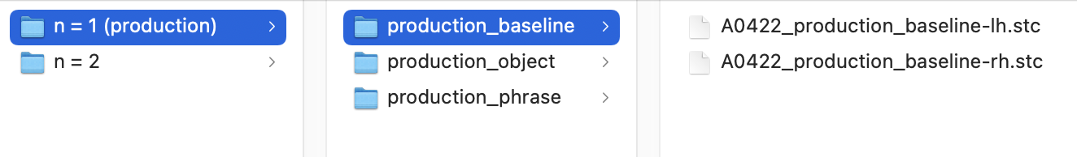

***STCs*: production data: *backwards averaging***

**6) to-do!!!**

***Plotting:* dialogue, reading, & listening data**

You will need **two scripts** for this section:

* **average_plotting_all_contrasts_sherine.py →** plots all contrasts *(eg: phrase vs object on one plot then phrase vs baseline on another etc)*
* **average_plotting_1_contrast_sherine.py →** plots a single contrast *(eg: phrase vs object vs baseline on one plot)*

In each of these scripts, you have to **edit 3 directories:**

* **The mri directory →** /Users/Sherine/Desktop/KidLang/mri
* **The stc directory →** /Users/Sherine/Desktop/KidLang/mrat/ ica bestreg free-3-dSPM/all_trials condition%task man eq/
* **The output directory →** /Users/Sherine/Desktop/KidLang/figs *(you have to create the ‘figs’ folder before running the scripts!*

**1)** Open terminal and change your working directory.

cd /Users/Sherine/Desktop/KidLang

**2)** Activate the eelbrain environment.

conda activate eelbrain

eelbrain

**3)** Open the **average_plotting_all_contrasts_sherine.py** script and go to line 9 where you have to put in your subject IDs. If you want to plot one subject, you change that line to include only 1 ID. If you want to plot the average of multiple subjects, change that line to include all the IDs. **SAVE!**

**4)** Run the **average_plotting_all_contrasts_sherine.py** script.

run average_plotting_all_contrasts_sherine.py

These are the plots you should get! *This script will, for example, plot object_listening and compare it to baseline_listening for the right & left hemisphere. Then it will do the same with phrase_listening vs baseline_listening, and then again with phrase_listening vs object_listening.*

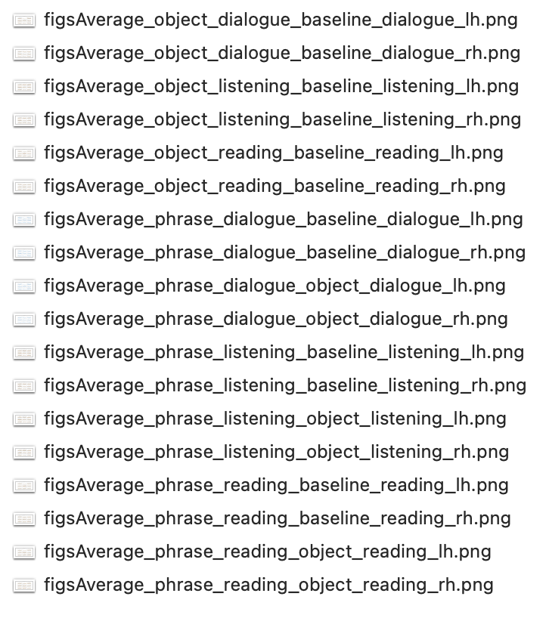

And this is what they look like!

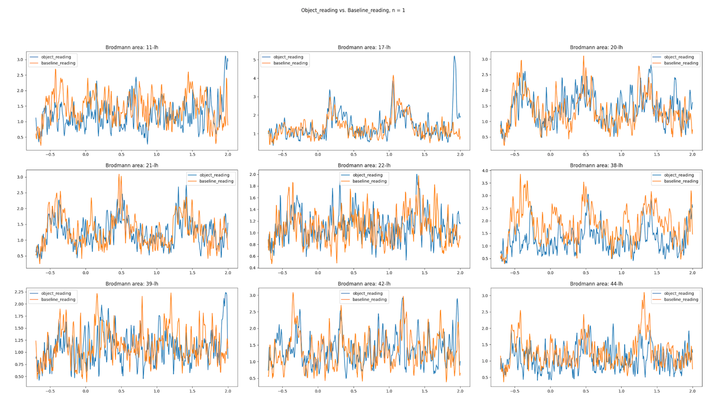

***NOTE:*** If you want to **quickly generate a plot with specific contrasts in mind,** and you don’t want to create all of the above plots and sort through them, there’s a part of the script (at the very bottom) titled *plot comparisons across tasks* that you can freely edit and have two plots generated (for both hemispheres).

**5)** In the **‘figs’** folder you created in /Users/Sherine/Desktop/KidLang/figs, create a folder called **‘all contrasts’** where you will put all plots generated from the **average_plotting_all_contrasts_sherine.py** script. Then, create subfolders with your participant IDs where you will put their plots, and another folder with all of your participants’ plots averaged.

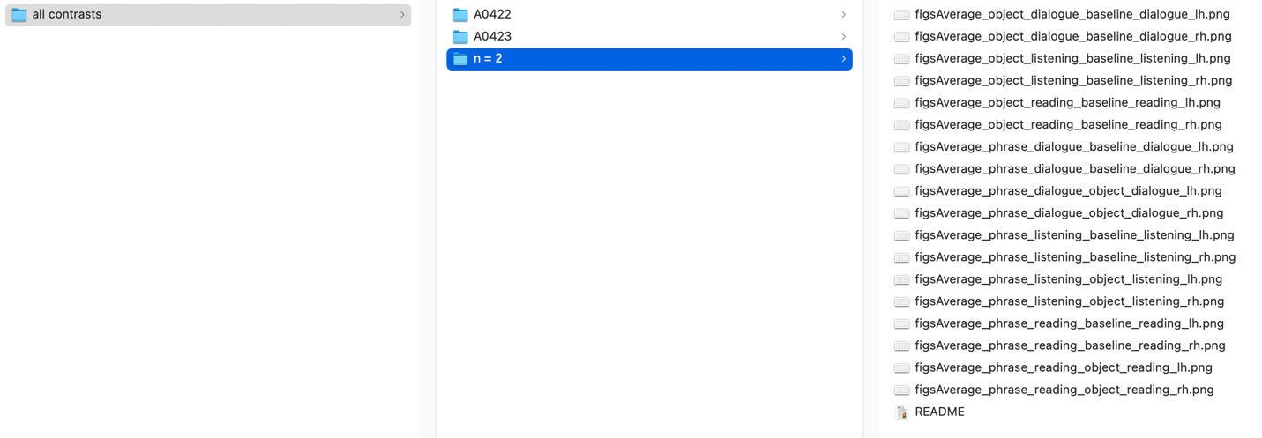

***Note****: the README file has information what tasks the plots show, and participant IDs*

**6)** Open the **average_plotting_1_contrast_sherine.py** script and go to line 11 where you have to put in your subject IDs. If you want to plot one subject, you change that line to include only 1 ID. If you want to plot the average of multiple subjects, change that line to include all the IDs. **SAVE!**

**7)** Then, run the **average_plotting_1_contrast_sherine.py** script.

run average_plotting_1_contrast_sherine.py

These are the plots you should get! *This script will, for example, plot all 3 conditions of the listening task in one plot, and then do the same for other tasks.*

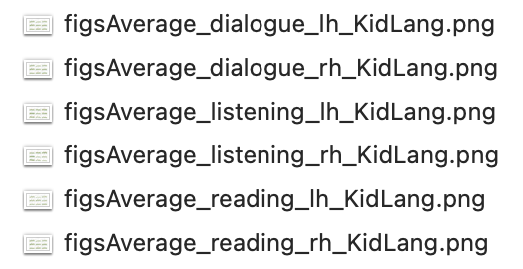

And this is what they look like!

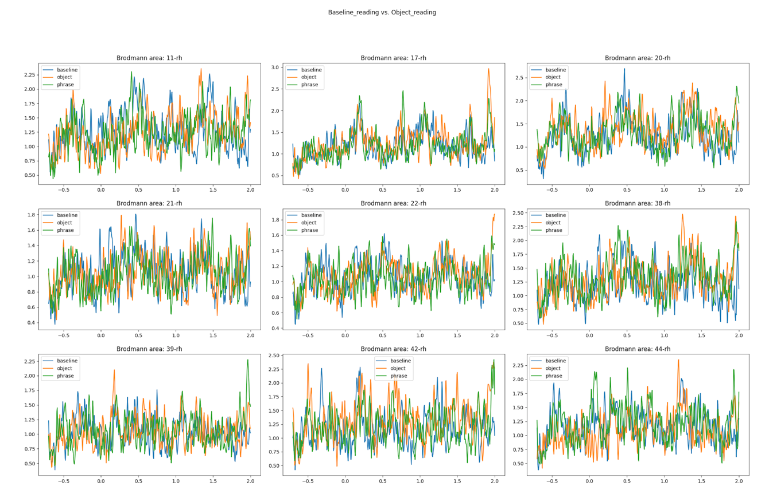

**8)** In the **‘figs’** folder you created in /Users/Sherine/Desktop/KidLang/figs, create a folder called **‘1 contrast’** where you will put all plots generated from the **average_plotting_1_contrast_sherine.py** script. Then, create subfolders with your participant IDs where you will put their plots, and another folder with all of your participants’ plots averaged.

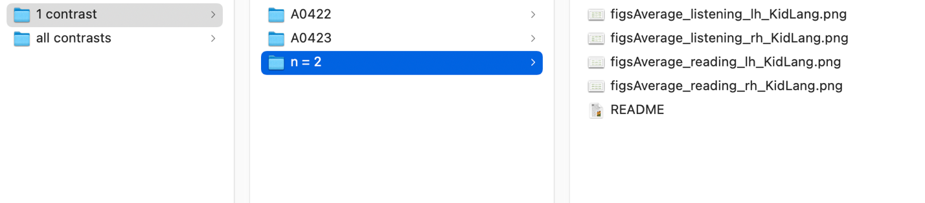

***Note****: the README file has information what tasks the plots show, and participant IDs. In this case, I also mentioned that there are no dialogue plots for these two participants as the trigger for phrase_dialogue wasn’t working.*

***Plotting:* production data**

***Notes***

This is just to talk about unspoken coding things that were not obvious to me when I first started.

Copy pasting the scripts into terminal

Using pip to install modules

Make sure all the folders you create are in lowercaps

If things aren’t working (eg guis not popping up) close and open terminal again

“points must be of shape (n, 3) instead of (8, 6) -> delete dx, dy, dz columns in points.txt

If you mislabel a participant don’t relabel